| **Test Name** | | | Push Notifications | | | |
| --- | --- | --- | --- | --- | --- | --- |
| **Use Case Tested:** | | | Play game-notify | | | |
| **Test Description:** | | | This test will check to see that at the end of the round a push notification is sent to the opponent telling them it is their turn | | | |
| **Pre-conditions** | | | Game must have two players  Minimum of one round played | | | |
| **Post-conditions** | | | That the user who initially started the game, player1, receives a push notifications to let them know it’s their turn | | | |
| **Notes:** | |  | | | | |
| **Result (Pass/Fail/Warning/Incomplete)** | | **Pass** | | | | |
|  | **TEST STEP** | | | **EXPECTED TEST RESULTS** | P | F |
|  | Player1 completes a round | | | The player can complete their turn | P |  |
|  | System sends a push notification to player one | | | Player1 receives a push notification telling them it’s their turn | P |  |

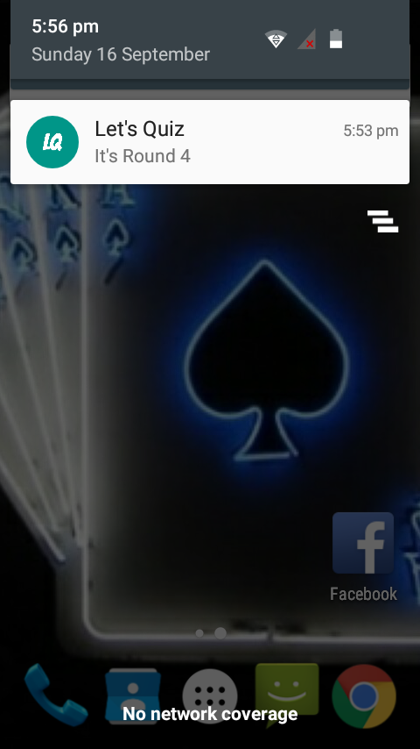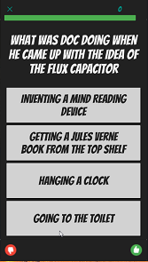

Player plays round Push notification sent